Suggested Mark Scheme

1 | Confusion arising from babies being mixed up in maternity wards is common in less developed countries. Couples may be raising a child that is totally unrelated to them for many months before they discovered phenotypic characteristics that are not possible to be inherited from them.  The identification of parentage is often done through genetic fingerprinting whereby restriction fragment length polymorphisms (RFLPs) are often revealed through Southern blotting.  The most common method is to characterise the variable number of tandem repeats (VNTRs) in the individuals involved as VNTRs are inherited.
 | (a) | Explain what is meant by tandem repeats.
 |  | - Multiples of the same sequence arranged consecutively;; | [1]
 |  | ® words used in question
In one such case, chromosome 13 was isolated from the DNA samples that were obtained from 3 couples who had their babies mixed up by a careless nurse. DNA was also obtained from the 3 babies for comparative analysis.

The DNA samples were subjected to Polymerase Chain Reaction (PCR) before analysis. Fig. 1.1 shows the temperature graph obtained from a PCR cycle.

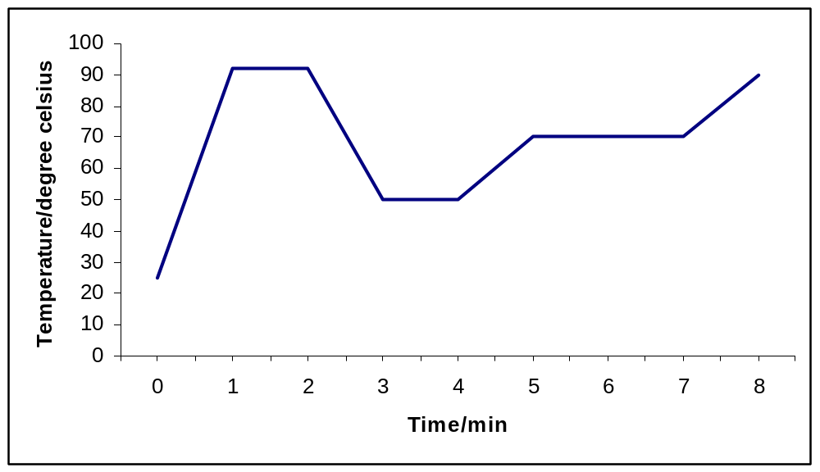
Temperature / ºC

Fig. 1.1

 | (b) | With reference to Fig. 1.1, account for the observed plateaus in temperature changes.
 |  | - 1st to 2nd min, 90ºC, denaturation phase;;
 |  | - H-bonds between complementary bases broken, resulting in ssDNA;;
 |  | - 3rd to 4th min, 50ºC, annealing/hybridization phase;;
 |  | - forward & reverse primers bind to ssDNA template via H-bonds btw complementary bp;;
 |  | - 5th to 7th min, 70ºC, elongation phase;;
 |  | - elongation of primers by Taq polymerase by bringing in free deoxyribonucleoside triphosphates;; | [6]
Fig. 1.2 shows a segment of chromosome 13 with 5' TTAGGAT 3' as the repeating unit and n is the number of repeats.

Fig 1.2

Fig. 1.3 shows the results of the autoradiograph obtained from the DNA analysis of the 3 couples and their babies.

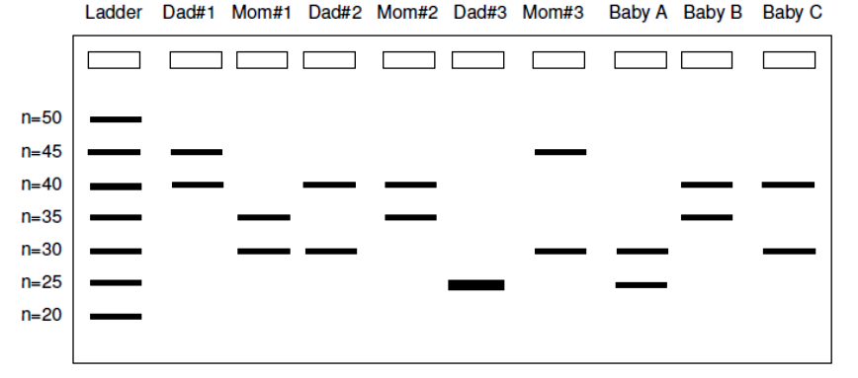

Fig. 1.3

 | (c) | With reference to Fig. 1.2 and 1.3,
 | (i) | state the purpose of the DNA ladder;
 |  | - for estimation of size of DNA bands;; | [1]
 | (ii) | explain why some bands are nearer to the wells of the agarose gel;
 |  | - gel acting as molecular sieve, distance travelled inversely proportional to molecular wt;;
 |  | - bands with a higher number of repeats/ bigger n will travel less;;
 |  | - Dad #1 and Mom #3 with n=45 travelled the least distance/ Dad #3 and Baby A with n=25 travelled the greatest distance;; | [3]
 | (iii) | explain why there is only a single band in Dad#3.
 |  | - Homozygous at the VNTR loci/ both chromosomes having the same number of repeats;; | [1]
 | (iv) | assuming faithful partners, conclude the parentage relationships for Baby A, B and C.
 |  | - Baby A has band at n=25 & n=30, coincides with Dad#3 and Mom #3;;
 |  | - Inconclusive for Baby B & C due to common bands with more than 1 pair of parents;;
 |  | - Give one e.g. to explain pt ;; | [3]
 | (v) | suggest an improvement to the procedure to obtain more accurate results.
 |  | - investigate more VNTR loci;; | [1]
 |  | [Total: 16]

2 | Gene therapy can be used to treat diseases such as cystic fibrosis by delivering normal genes into cells. However, very different strategies of gene therapy are used to treat cancer.  In what is called 'suicide therapy', a gene such as the herpes simplex virus thymidine kinase gene (HSV-TK) is transferred to tumour cells. The enzyme phosphorylates the nucleoside thymidine. The HSV-TK gene is not normally found in the human body.  After building up high levels of TK activity in the tumour after several rounds of gene therapy, ganciclovir, a base analog inactive in normal cells, is given to the patient. In the presence of HSV-TK, ganciclovir is converted from a non-toxic prodrug to its active phosphorylated form, killing the tumour cells by disrupting DNA synthesis.  Table 2 shows the effect of HSV-TK and ganciclovir levels on tumour cells.  Table 2
  HSV-TK levels / arbitrary units | Ganciclovir dosage / arbitrary units | Percentage cell death in tumour / %
  5 | 20 | 35
  10 | 20 | 38
  10 | 80 | 56
 | (a) | Explain what is meant by gene therapy.
 |  | - to treat genetic disease by introducing a normal allele or correcting a disease-causing allele;; | [1]
 | (b) | Using information from the passage, suggest how HSV-TK and ganciclovir work together to kill cancer cells.
 |  | - HSV-TK phosphorylate ganciclovir which acts as a thymine analog;
 |  | - used by DNA pol in place of T during DNA replication but does not allow further elongation / terminates elongation;
 |  | - tumour cells unable to complete genome replication thus cell division, undergoes apoptosis; | [3]
 | (c)(i) | Explain why gene therapy for cancer cannot take the same approach as that of diseases like cystic fibrosis.
 |  | - cancer caused by multiple genes;
 |  | - cancer due to effects of gain-in-fn mutation acting as dominant allele which intro of normal allele does not negate; | [2]
 | (ii) | State one advantage of using 'suicide gene therapy' compared to traditional forms of cancer therapy like chemotherapy.
 |  | 1. high tissue specificity, chemo kills all actively dividing cells; | [1]
 | (d) | With reference to Table 2, explain the effects of HSV-TK and ganciclovir on tumour cells.
 |  | -  in HSV-TK from 5 to 10 units with low dose ganciclovir of 20 units cause slight  in cell death from 35% to 38% (3%);
 |  | - high ganciclovir of 80 units with 10 units of HSV-TK cause large  in cell death from 38% to 56% (18%);
 |  | - ganciclovir conc. is limiting factor / HSV-TK needed in small amts;
 |  | - requires high levels of both to cause high % of cell death; | [2]
 | (e) | Genes delivered using non-viral vectors often experience less target tissue specificity and transient gene expression.
 | (i) | Explain why delivering the HSV-TK gene using non-viral vectors does not limit the efficacy of the treatment.
 |  | - efficacy not affect by transient gene expression as trmt  need long term gene expression which kills cells within short period of time;
 |  | - not affected by low tissue specificity during HSV-TK delivery as non-target cells without ganciclovir will not cause cell death; | [2]
 | (ii) | Suggest two reasons why gene expression is often transient when using non-viral vectors.
 |  | - degradation of non-integrated gene;
 |  | - gene not propagated to daughter cells; | [2]
 |  | [Total: 13]

3 | The carp is a freshwater fish which became a pest when it was introduced to Australia in the 1970's. The authorities have traditionally attempted to control carp numbers by physically excluding carp from suitable breeding sites.  Recently, scientists are trying to control the carp by using antisense gene technology. A transgene inserted into carp embryos prevents the production of an enzyme, aromatase. The enzyme is responsible for a key step in the biosynthesis of oestrogens, a female hormone. The presence of the transgene causes female embryos to develop into males.  The concept is that large numbers of carp containing the transgene would be bred in hatcheries and released into the wild. Over time, this will result in the reduction of the carp population.  Fig. 3 shows section of the aromatase gene and the inserted transgene.  5' … TGGCTA … 3' 5' … TAGCCA … 3'  aromatase gene transgene  Fig. 3
 | (a) | Suggest why the carp became a pest when it was introduced into Australia.
 |  | - lack of natural predator thus  in population;;
 |  | - outcompete native species, toppling ecological balance;; | [1]
 | (b)(i) | With reference to Fig. 3, explain how the insertion of the transgene causes carp female embryos to develop into males.
 |  | - transgene transcribed to 3' AUCGGU 5' RNA, aromatase mRNA 3' ACCGAU 5';
 |  | - act as antisense RNA, bind by complementary base pairing via H bonds to form ds RNA;
 |  | -  ribosome binding, thus  translation into aromatase, leading to  oestrogen pdtn, lack of female hormones cause embryos to dev into males; | [3]
 | (ii) | Describe how genetically modified carp embryos can be obtained.
 |  | - microinjection of transgene into embryo;
 |  | - select embryo with integrated transgene;
 |  | - liposome;
 |  | - package trangene into phospholipids sphere, allow fusion with carp cell;
 |  | - AVP method;
 |  | - AVP elaboration; | [2]
 | (iii) | Suggest why several genetically modified carp embryos still developed into female adults.
 |  | - transgene not integrated, thus loss or degraded;
 |  | - integrated into heterochromatin region ® non-coding region; | [1]
 | (c) | Explain how releasing genetically modified carp would result in a reduction in wild carp population over time.
 |  | - GM carp breed with wild carp, pass transgene to offspring, offspring becomes male;
 |  | - results in > males than females, ering repro potential of popn; | [2]
 | (d) | The use of gene technology in controlling carp population has advantages over current methods but has also raised concerns. State
 | (i) | one advantage;
 |  | - specific to carp,  affect other fish sharing breeding site; | [1]
 | (ii) | one concern.
 |  | - gene flow occurs when GM carp breeds with close relative species causing  in popn of non-targeted species; | [1]
 |  | [Total: 11]

4 | Planning  You are required to plan, but not carry out, an investigation into the effect of intensity of light on the rate of photosynthesis.  Photosynthetic rates in plants are affected by both quantity and quality of light. The light intensity and wavelength of light optimum for photosynthesis varies between plant species and even cultivars.  Your planning must be based on the assumption that you have been provided with the following equipment and materials:  - photosynthetic plant (aquatic or terrestrial)  - sharp knife and white tile for cutting  - NaHCO₃  - table lamp (60W)  - distilled water  - metre rule  - plastacine  - conical flasks  - filter funnel  - burette  - rubber tubing  - a variety of different sized beakers, measuring cylinders, syringes and pipettes for measuring volumes  [Total: 12]
- theoretical background (2m)
- variables
- rationale of procedure
- procedure (2m)
- safety
- accuracy and reliability
- collection of results
- layout of results
- diagram of setup
- terminology

5 | Write your answers on the separate answer paper provided.  Your answer:  - should be illustrated by large, clearly labelled diagrams, where appropriate.  - should be in continuous prose, where appropriate.  - must be set out in section (a), (b) etc., as indicated in the question.
 | (a) | Explain how gel electrophoresis is used to analyse DNA. [6]
- agarose gel acting as molecular sieve to separate fragments based on molecular size;;
- distance travelled by band is inversely proportional to molecular size;;
- presence of TAE/TBE buffer provide the ions to support conductivity;;
- application of direct current enables the neg charged DNA to travel to the positive electrode;;
- gel stained with methylene blue to reveal positions of DNA bands;;
- relative thickness of band is an indication of the amount of DNA with that molecular size;;
 | (b) | Outline the process of nucleic acid hybridisation and explain how it can be used to detect and analyse restriction fragment length polymorphism (RFLP). [5]
- Lay nitrocellulose paper on the electrophoresed gel submerged in NaOH with a stack of paper towels;;
- dsDNA denatured into ssDNA, adhere to nitrocellulose paper;;
- placed into bag with radioactive ssDNA probe with complementary sequences to target sequences;;
- Excess probe washed off and placed on X-ray film, hybridized areas will show up as dark bands;;
- banding patterns is an indication of number of fragments and fragment length that can be compared to other DNA samples;;

 | (c) | Explain how RFLP analysis facilitated the process of linkage mapping, diseases detection and DNA fingerprinting. [9]
- RFLP is based on variation in no. & length of restriction fragments btw individuals visible through gel electrophoresis / nucleic acid hybridization / Southern blotting;;
Linkage Map
- shows the relationship between 2 or more genes located on the same chromosome
- tightly linked RFLP with genes are used as DNA markers for respective genes where linkage are calculated based on the recombinant phenotype freq;;
Disease detection
- disease causing allele differs from normal allele due to mutation, may result in the lost/creation of a restriction site in the mutated allele;;
- RFLP marker is closely linked to or within disease causing allele, resultant fragments from RE digestion can indicate presence / inheritance of specific allele;;
DNA fingerprinting
- DNA profiling process identifying individuals based on diff in repetitive DNA sequence e.g. VNTR
- Different number of repeats within a restriction site results variable length of fragments formed after RE digestion;;
- Analysis is based on matching DNA fingerprint between samples;;
- perfect match in parentage identification/ criminal analysis or degree of similarity in evolutionary studies;;

 |  | [Total: 20]

